**12 PSYCHOLOGY SHORT-TERM MEMORY THROUGH**

**SERIAL POSITION EFFECT INVESTIGATION 2016**



Name:__________________________ Form:_________________

Teacher: Miss Cerny Due date: Tuesday 9th August

**Broad context:** Cognition.

**Task type:** Investigation.

**Key concepts:**

Short-term memory.

Research designs.

**Task:**

You will be examining your short-term memory through the serial position effect. Specifically, you will investigate whether your ability to recall items from a list reflects the pattern suggested by the serial position effect.

Participants in this investigation will be required to remember and recall as accurately as possible sets of ten digits in the order they are presented. Participants will be presented with five sets of digits and will be given the chance to recall the digits at the end of each set on a provided data sheet. The data collection for this investigation will take place during regular class time.

**Hand in the following:**

⬩ This assessment booklet.

⬩ Your typed-up final report.

**Recommended resources:**

Video: Serial Position Effect - Intro to Psychology: 1:19min: *https://www.youtube.com/watch?v=lreVhYo6V_E*

Video: Memory - Forgetting Curve and Serial Position Effect: 14:18min: *https://www.youtube.com/watch?v=htPQDc8gzF0*

Text: Psychology Self and Others: pg 178-183

Text: Nelson Psychology VCE Units 3&4

Text: Psychology First European Edition pg 169-211

**Information to focus on**

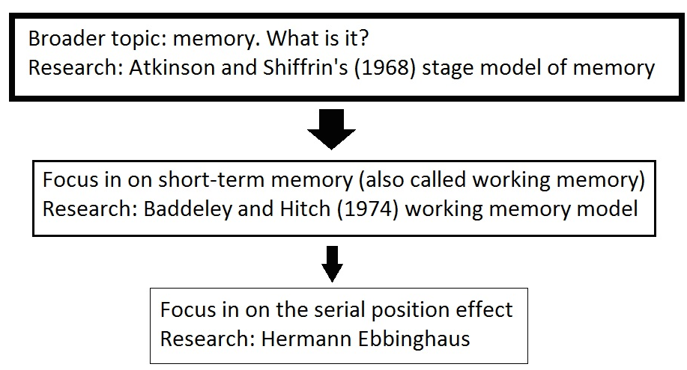

**Investigation: Short-term memory through the serial position effect**

**Individual data sheet**

|  |  |  |  |  |  |  |  |  |  |  |
| --- | --- | --- | --- | --- | --- | --- | --- | --- | --- | --- |
|  | **Digit #1** | **Digit #2** | **Digit #3** | **Digit #4** | **Digit #5** | **Digit #6** | **Digit #7** | **Digit #8** | **Digit #9** | **Digit #10** |
| **Set 1** |  |  |  |  |  |  |  |  |  |  |
| **Set 2** |  |  |  |  |  |  |  |  |  |  |
| **Set 3** |  |  |  |  |  |  |  |  |  |  |
| **Set 4** |  |  |  |  |  |  |  |  |  |  |
| **Set 5** |  |  |  |  |  |  |  |  |  |  |
|  | | | | | | | | | | |
| **Number of correct responses** |  |  |  |  |  |  |  |  |  |  |

In the table below, record the digits that you can recall from each set in the order they were presented to you. If you do not remember a digit, put a line through the box.

|  |  |  |  |
| --- | --- | --- | --- |
| **Content** | **Description** |  | **Mark** |
| Abstract | Very brief aim in one sentence.  Short description of participants and their characteristics (number, ages, genders).  Short description of the procedure (what the participants did, how data was collected).  Short summary of results.  Statement claiming whether hypothesis was supported or not supported.  Short summary of conclusion.  Correct structure of abstract (correct order of information, in past tense). | 1  1  1  1  1  1  1 |  |
| Introduction | Explained background knowledge:  - Explained what memory is.  - Described main features of short-term memory.  - Explained the serial position effect.  Described two (2) past research/relevant psychological theories referred to in this field.  Includes correctly written citations.  Correctly formed operational hypothesis.  Correct structure of introduction (correct order of information, correct tense used). | 1  2  2  2  1  1  1 |  |
| Method | Participants:  Details of the sample (from what population they were drawn, how they were selected).  Number of participants used.  Ages and genders of participants.  Materials: description of items used to conduct study.  Design: stated operationalised independent variable and operationalised dependent variable.  Procedure: includes all the steps completed in the experiment.  - Addresses anonymity.  Correct structure of method (in sentences, correct order of information, in past tense). | 1  1  1  1  1  2  1  1 |  |
| Results | Results explained in words (refer to the graph in the text).  Collated table with average class results (can be done on computer or hand drawn).  Graph showing average class results - needs to be **hand drawn**.  Correct structure of results (titles of table and graph in correct positions, in past tense). | 2  1  5  1 |  |
| Discussion | Statement claiming whether or not results support the hypothesis.  Compared findings to those in past research/relevant psychological theories discussed in intro and explain any differences or similarities in results.  Mentioned publications are correctly cited.  Discussed two (2) uncontrolled variables.  - How each variable may have affected results.  - Suggestions on aspects of study design and procedure that could be improved to get better  results.  Conclusion of what the study showed.  Correct structure of discussion (correct order of information, in past tense). | 1  2  1  2  2  2  1  1 |  |
| References | Minimum of two references.  Referenced according to the APA format.  Correct structure of reference list (indentations, correct spacing, no hyperlinks, in alphabetical order). | 1  1  1 |  |
| Appendices | Includes raw average class data table with relevant headings. (Can be done on computer or hand drawn).  Correct structure of appendices (each appendix on new page). | 2  1 |  |
| Presentation | Times New Roman font, 12 point, 1.5 line spacing.  Left and right sides of page indented by 3cm.  Page numbers at bottom of pages.  Formal and scientific language used (no personal language, no slang or contracted words).  Correct spelling and grammar. | 1  1  1  1  1 |  |
| **Total mark** | | 58 |  |

Mark as percentage: %

Teacher’s comments: on Seqta